User

Manual

**Version 2.1**

|  |  |
| --- | --- |
| ***Corporate Office*** | ***Offshore Development Center*** |
| *1 Pickering Street*  *#06-03 Great Eastern Centre*  *Singapore 048659* | *Plot # 122 & 123, N.S.E.Z, Phase -2*  *NOIDA, UP 201 305*  *India*  *Tel: 91.11.91.2510483* |

|  |  |  |  |  |
| --- | --- | --- | --- | --- |
| **Author** | | | | |
| **Name** | **Role** | **Date of Preparation** | **Signature** | |
| Varun Gupta | Business Analyst | 30-Jan-2015 | Varun | |
| **Reviewer(s)** | | | | |
| **Name** | **Role** | **Date of Review** | **Signature** | |
| Pravesh Kumar | Manager Projects |  |  | |
|  |  |  |  | |
| **Approver** | | | | |
| **Name** | **Role** | **Date of Approval** | **Signature** | |
| ChengChoon Yip | VP Ebix Exchange  Asia |  |  | |
| **Document Path** | **Version Number** | **Date of Release** | | |
|  |  |  | | |
|  |  |  | | |
| **Revision History** | | | | |
| **Version Number** | **Date of Release** | **Section/ Page # Changed** | | **Details of Changes** |
|  |  |  | |  |
|  |  |  | |  |

|  |  |  |
| --- | --- | --- |
| **References** | | |
| **Document** | **Date Received** | **Author** |
|  |  |  |

Contents

1. Home Screen 6

2. Upload Main Menu 7

2.1 Browse Screen 8

2.1.1 Field Validation 8

2.1.2 Dependencies 8

2.1.4 Outcome 9

2.1.5 Search criteria section 10

2.2 Bus Captain Listing Screen 11

2.2.1 Add Screen 12

3. Department Master Creation 13

3.1 Description: 13

4. Insurer Master 14

4.1 Screen Description 14

4.2 Field Validations 15

4.3 Dependencies 15

4.4 Outcome 15

4.5 Messages Handling 15

5. Surveyor Master 16

5.1 Add Screen will add bus captain record in application 16

5.2 Field Validations 16

5.3 Dependencies 16

5.4 Outcome 16

5.5 Messages Handling 16

6. Lawyer Master 17

6.1 Add Screen will add bus captain record in application 17

6.2 Field Validations 18

6.3 Dependencies 18

6.4 Outcome 18

6.5 Messages Handling 18

7. Workshop Master 18

7.1 Add Screen will add bus captain record in application 19

7.2 Field Validations 19

7.3 Dependencies 19

7.4 Outcome 20

7.5 Messages Handling 20

8. Adjuster Master 20

8.1 Add Screen will add bus captain record in application 20

8.2 Field Validations 21

8.3 Dependencies 21

8.4 Outcome 21

8.5 Messages Handling 21

9. Hospital Master 21

9.1 Add Screen will add bus captain record in application 22

9.2 Field Validations 22

9.3 Dependencies 23

9.4 Outcome 23

9.5 Messages Handling 23

10. Organization 23

10.1 Screen Description 24

10.2 Field Validations 24

10.3 Dependencies 24

10.4 Outcome 24

10.5 Messages Handling 24

11. Deductible Master 25

11.1 Add Screen will add bus captain record in application 25

11.2 Field Validations 25

11.3 Dependencies 25

11.4 Outcome 25

11.5 Messages Handling 25

# Home Screen

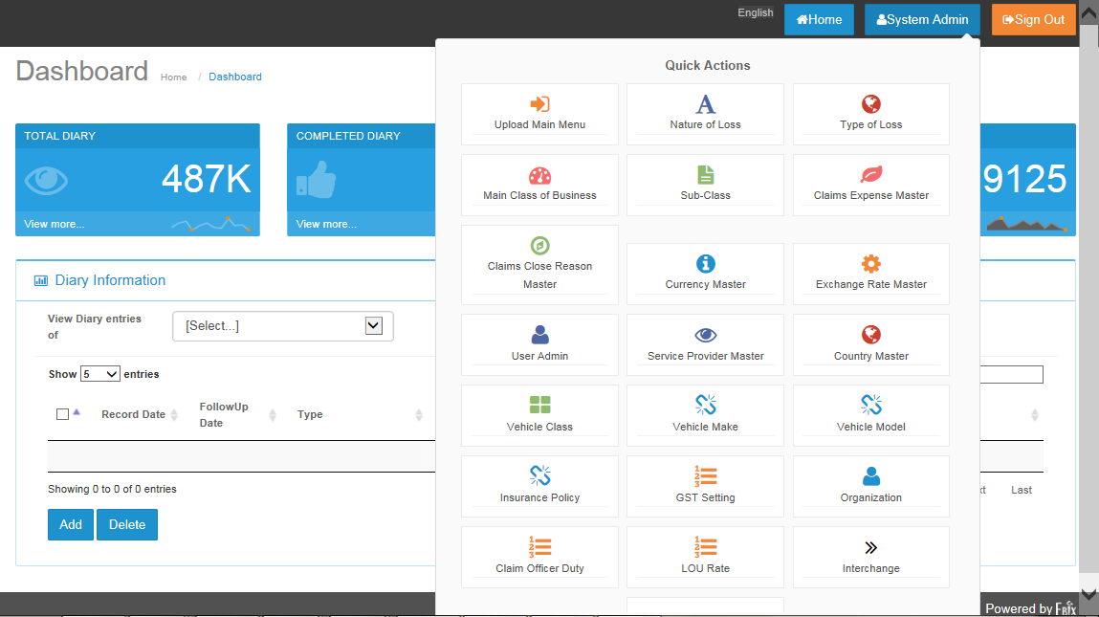

* Click on  to see Master list.

# Upload Main Menu

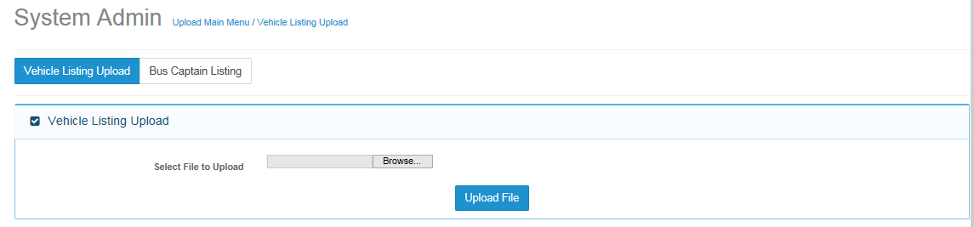

* Click on  button to view Vehicle listing upload screen.
* First section will be interface to upload file.

## Browse Screen

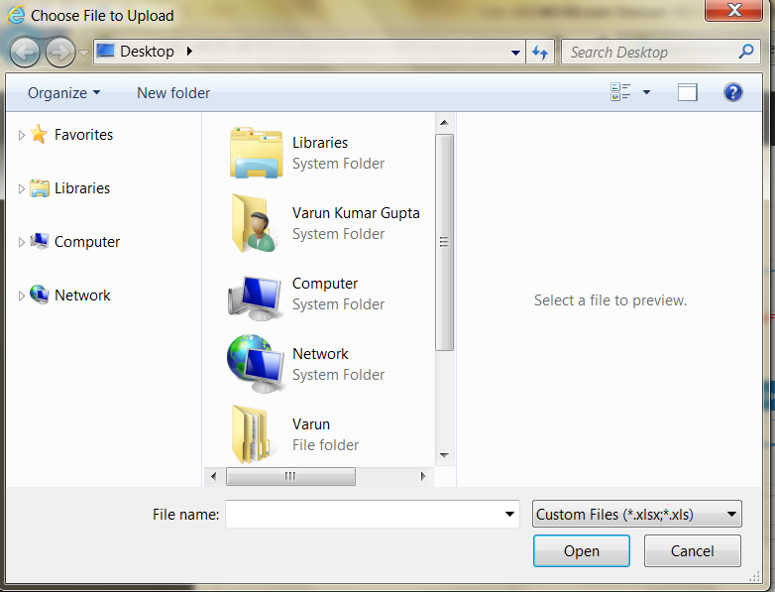

* Click  button to search for file to be uploaded.

### Field Validation

* Excel file needs to be inserted
* File must have 6 columns
* File with blank records , will not be allowed for insertion
* Duplicate file cannot be uploaded.

### Dependencies

* No Dependencies on file upload operation
  + 1. Message Handling
       1. Error Message
* ~~If user not select any file and click on browse button. Below Error message will come.~~
* If user does not select any file and click on Upload File. The below error message will appear.



### Outcome

* Record will be saved in database and shown in search result grid as following.

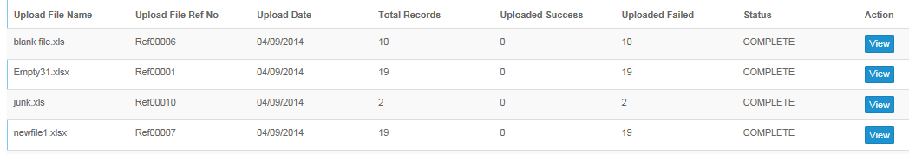

### Search criteria section

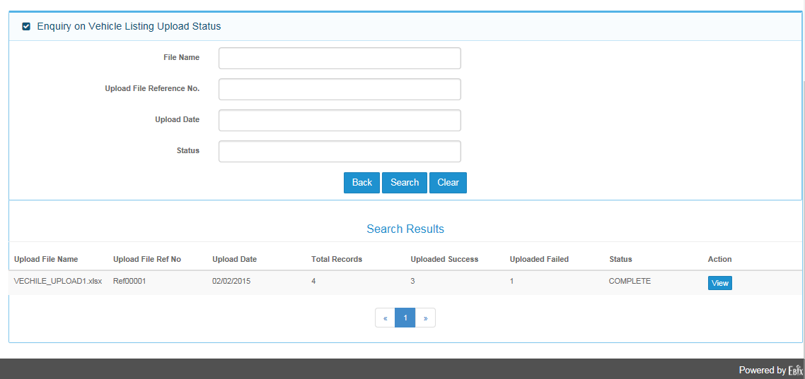

* Enter either File name, Upload File reference No. , upload Date or Status to search file .
* Click  to view search results
* Click  to go back to vehicle upload listing main screen
* Click  to clear inserted content
* Search Result section will show by default oldest created record
* By clicking on left and right ~~aero~~ arrows user can also navigate search result screen.

## Bus Captain Listing Screen

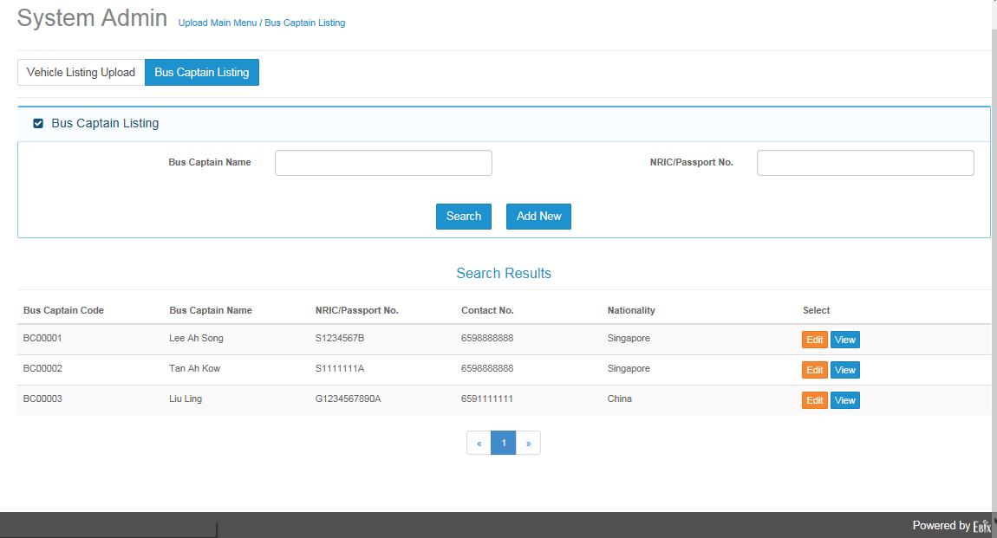

* Bus Captain Listing is having Search criteria , Search Results
* On search criteria fill either “Bus captain name or NRIC/Passport No. “
* Click  button ~~for searching existed record~~ to search for existing record.
* Click  button to add bus captain record.
* Click  button to edit selected record.
* Click  button to view selected record.

### Add Screen

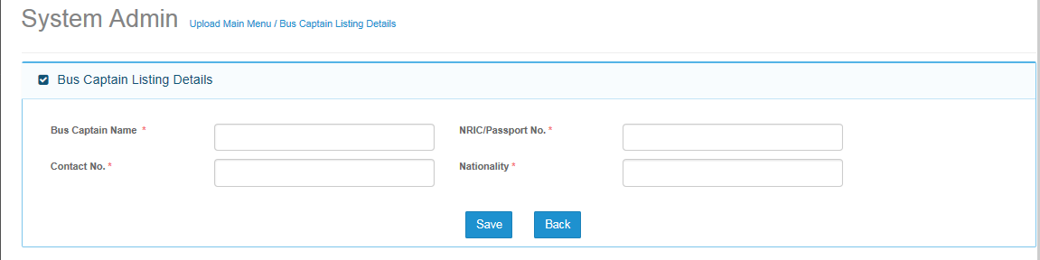

#### Screen Description

* Bus captain listing file will be used to add bus captain information.

#### Field Validations

* Bus Captain name :
  + Maximum length 75
  + Mandatory
* Contact no.
  + Maximum length 15
  + Mandatory
* NRIC/Passport No.
  + Maximum length 40
  + Mandatory
* Nationality
  + Maximum Length 80
  + Mandatory

#### Dependencies

* Not Applicable

#### Outcome

* Record will be saved in database.
* Record will ~~come~~ appear in search screen

#### Messages Handling

* Error message will ~~come~~ appear , if user did not enter bus captain code and ~~direct~~ clicked on save button.



# Department Master Creation

## Description:

Department Master is use to Create department of organization.

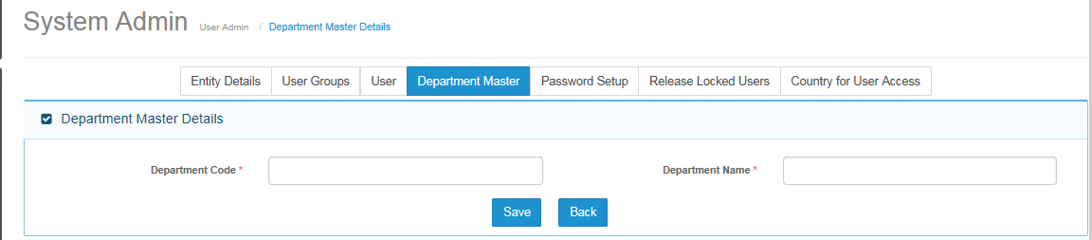

### Screen Description

### Field Validations

### Dependencies

### Outcome

### Messages Handling

# Insurer Master

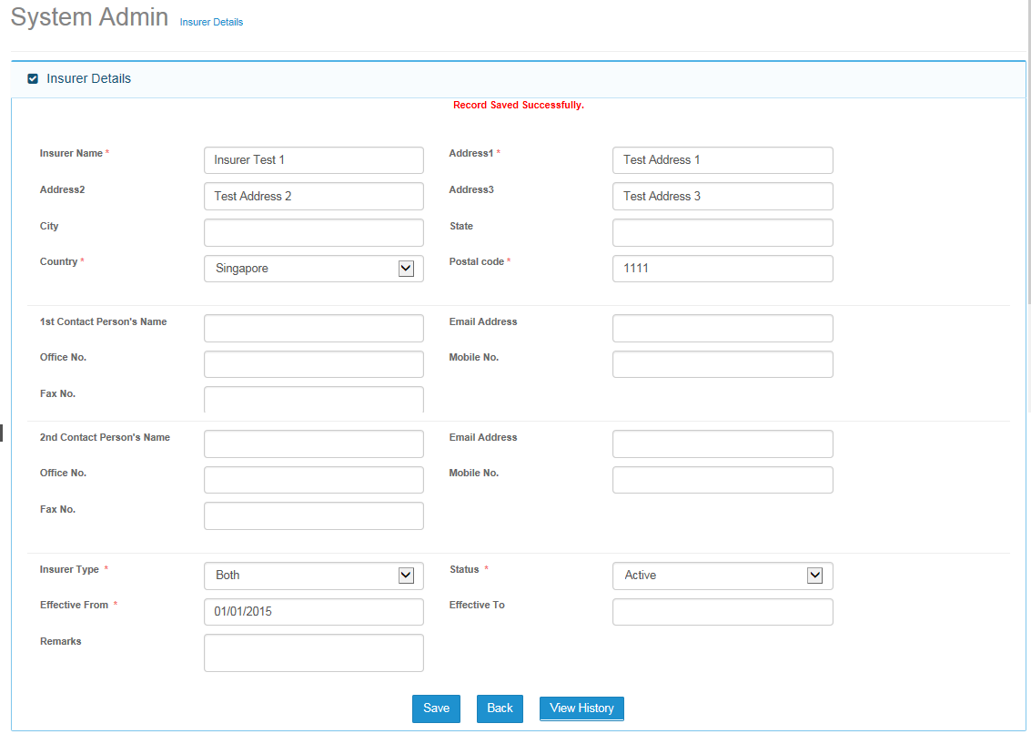

## Screen Description

## Field Validations

## Dependencies

## Outcome

## Messages Handling

# Surveyor Master

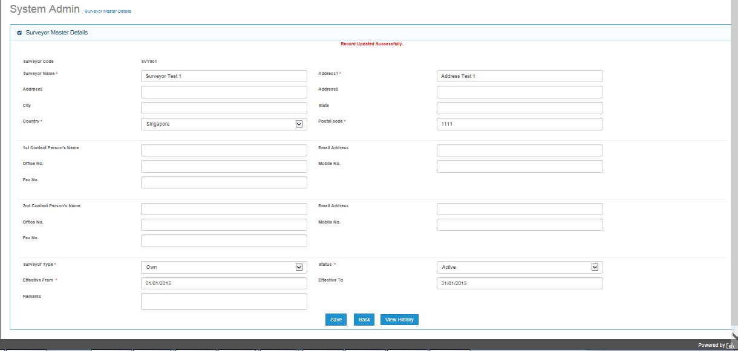

## Add Screen will add bus captain record in application

## Field Validations

## Dependencies

## Outcome

## Messages Handling

# Lawyer Master

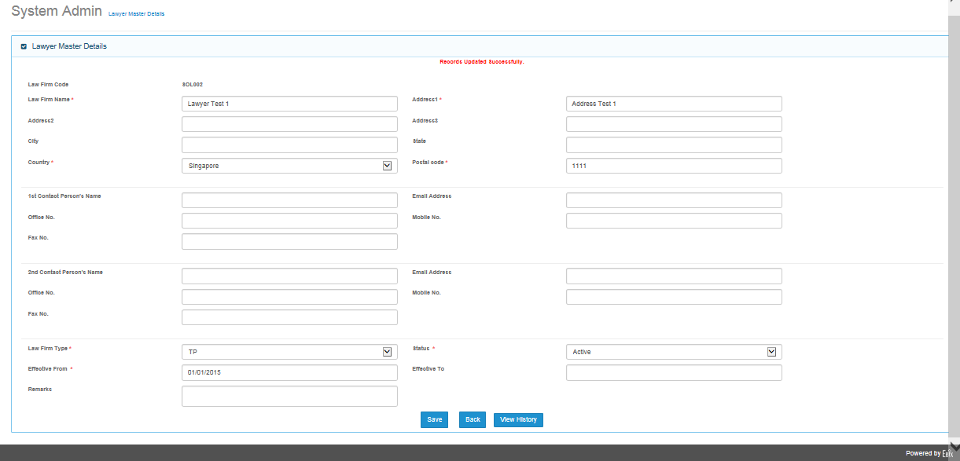

## Add Screen will add bus captain record in application

## Field Validations

## Dependencies

## Outcome

## Messages Handling

# Workshop Master

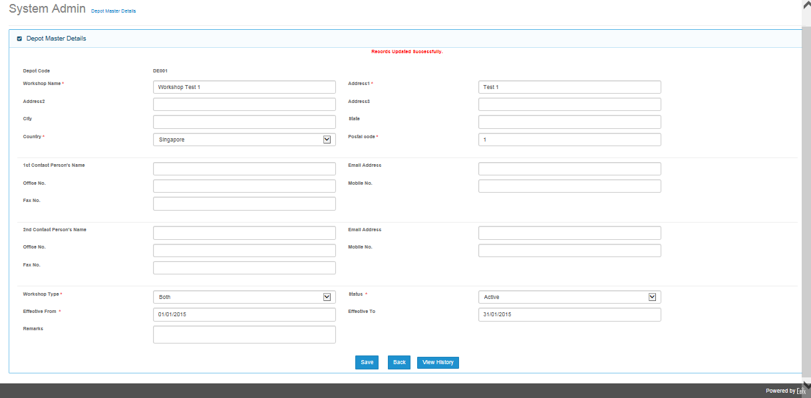

## Add Screen will add bus captain record in application

## Field Validations

## Dependencies

## Outcome

## Messages Handling

# Adjuster Master

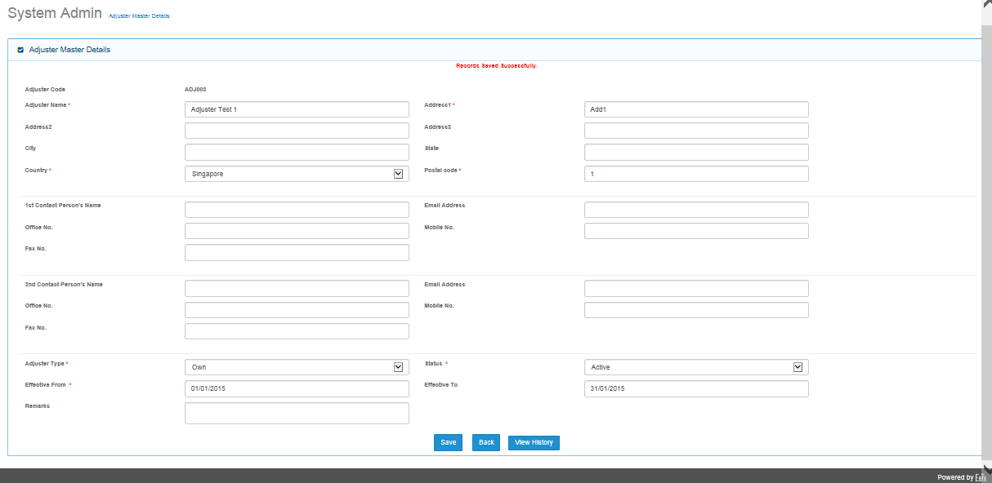

## Add Screen will add bus captain record in application

## Field Validations

## Dependencies

## Outcome

## Messages Handling

# Hospital Master

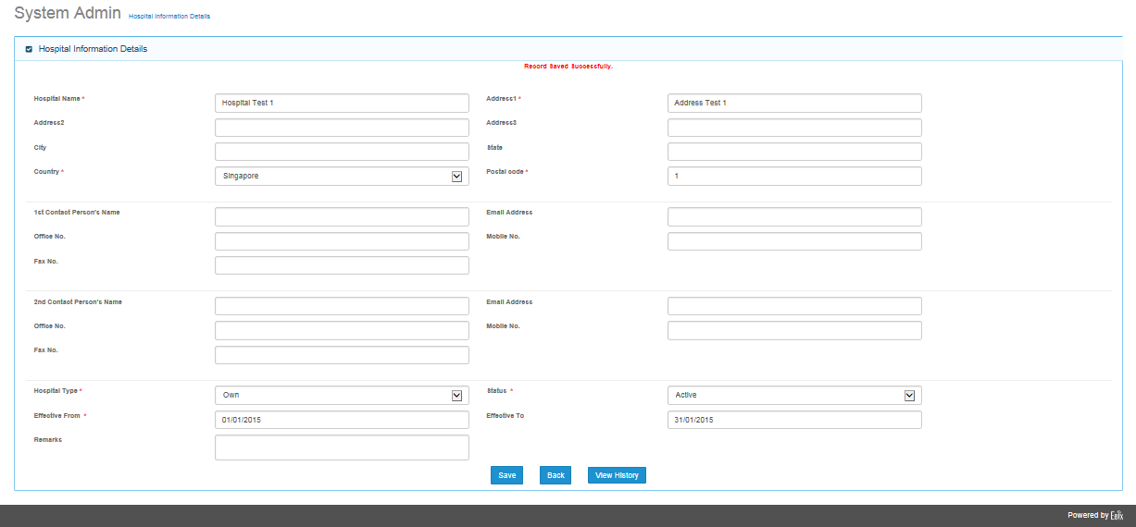

## Add Screen will add bus captain record in application

## Field Validations

## Dependencies

## Outcome

## Messages Handling

# Organization

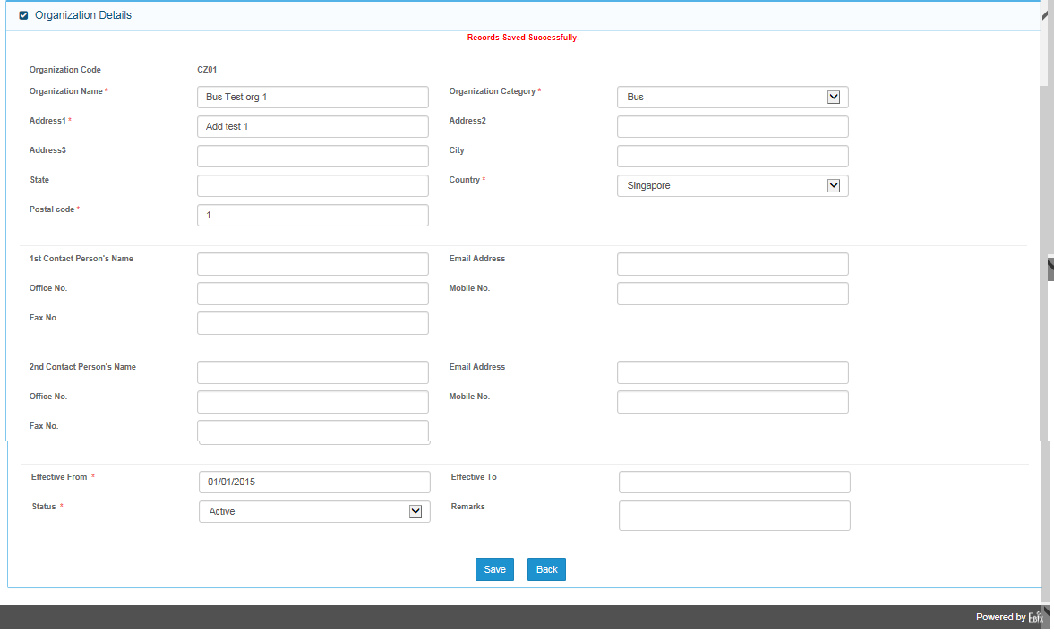

## Screen Description

## Field Validations

## Dependencies

## Outcome

## Messages Handling

# Deductible Master

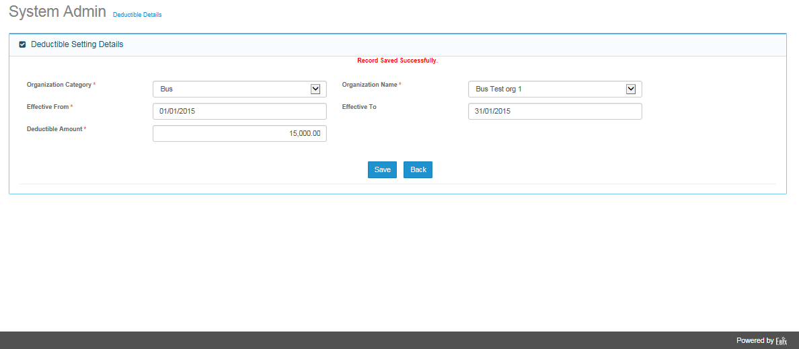

## Add Screen will add bus captain record in application

## Field Validations

## Dependencies

## Outcome

## Messages Handling